Title: RoboSep-S upgrade procedure

Author: Chulwoong Jeon

Date: May 14, 2014

RoboSep-S describes RoboSep-S upgrade procedures. This procedure will upgrade from RoboSep-S v1.0.3.0 to RoboSep-S v1.0.4.0

1. Run ‘Update_RoboSep-S.exe’. A following dialog box will be shown. Clcik ‘Yes’.

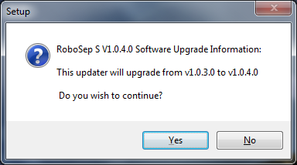

1. When a following dialog box is shown, click ‘Next’ button.

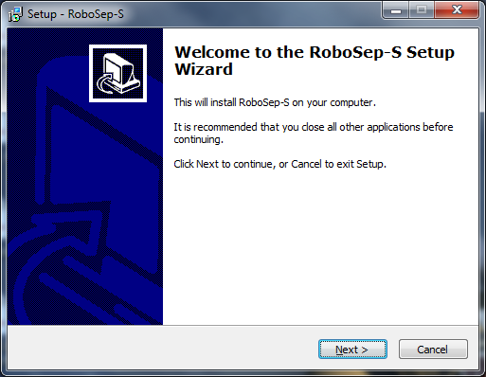

1. A following dialog box will be displayed. Click ‘Install’.

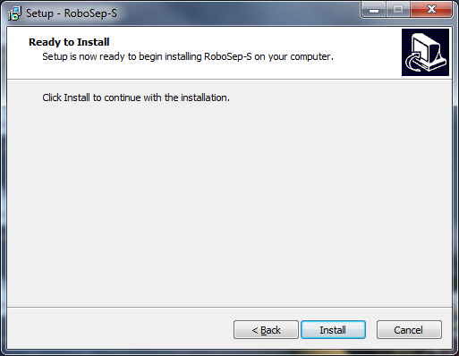

1. Uninstalling previous version programs will be starting. You will see a screen below. Please wait until the screen goes away.

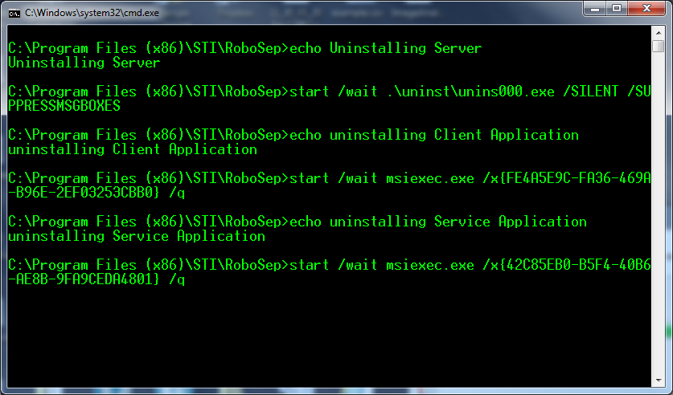

1. Installing RoboSep-S server will be starting. Click ‘Next’ button at a following screen.

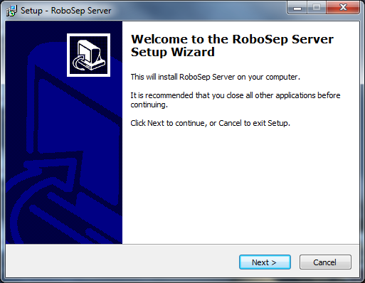

1. Click ‘Next’ button at a following screen.

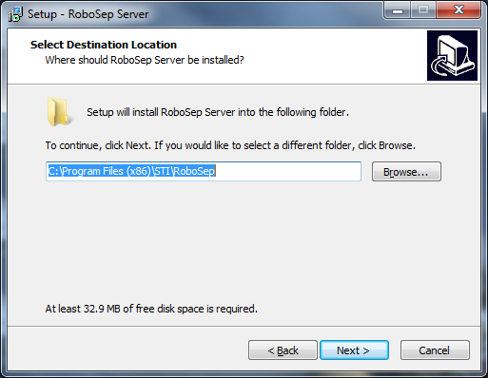

1. Select **‘Manual Configuration’** and click ‘Next’ button at a following screen.

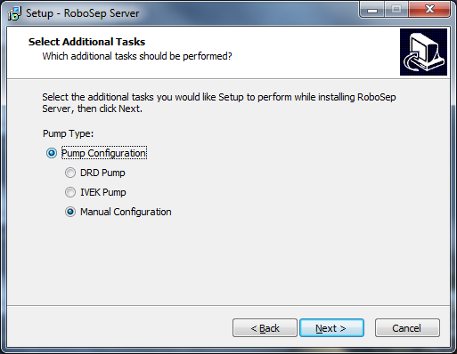

1. Click ‘Install’ button. Copying files will be performed.

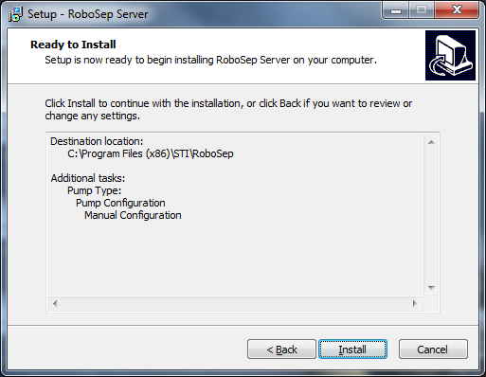

1. When a following dialog box is popped up, click ‘OK’.

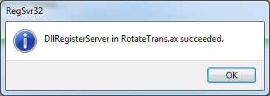

1. RoboSep-S server upgrade is completed. Click ‘Finish’ button.

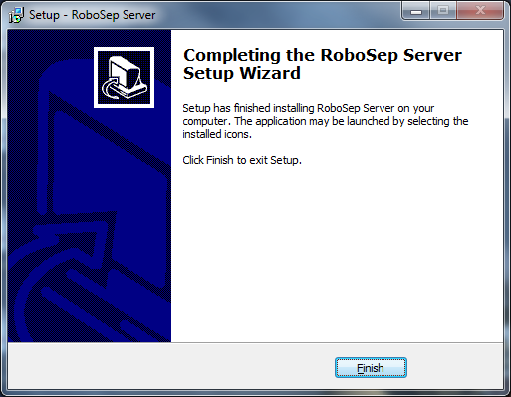

1. Upgrading RoboSep-S Client is started. Click ‘Next’ button.

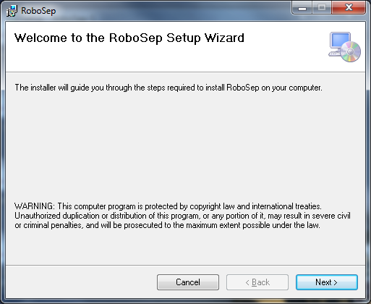

1. Click ‘Next’ button when you see a following dialog box.

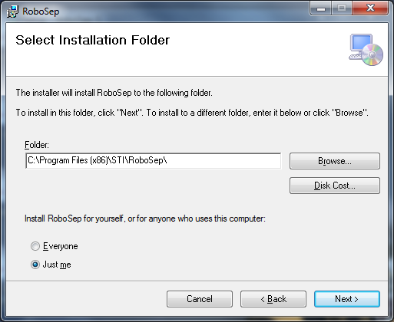

1. Click ‘Next’ button. Copying files will be starting.

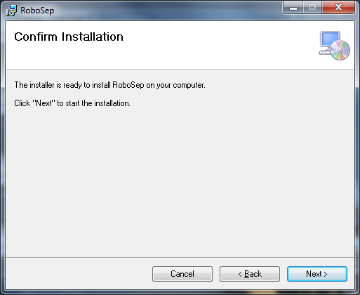

1. Upgrading RoboSep-S Client is completed. Click ‘Close’ button.

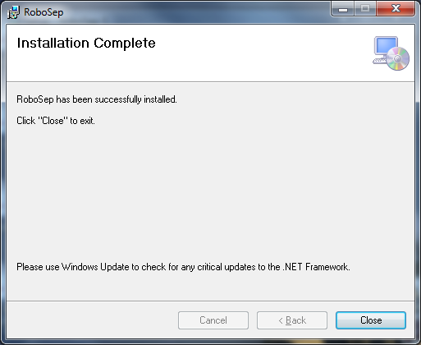

1. Upgrading RoboSep-S Service program will be staring. Click ‘Next’ button when a following dialog box is popped up.

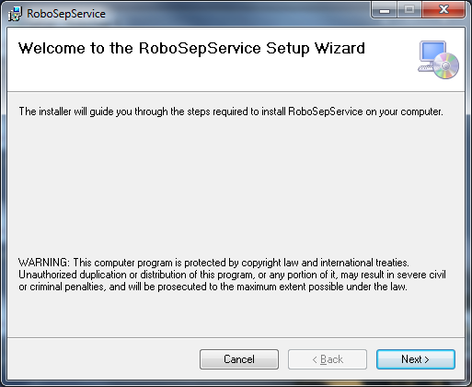

1. Select ‘Next’ button at a following screen.

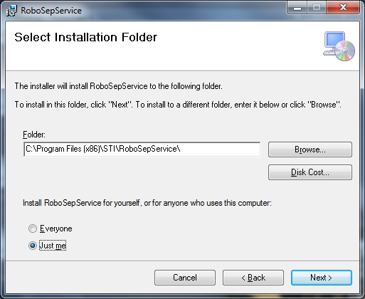

1. Click ‘Next’ button. Copying files will be starting.

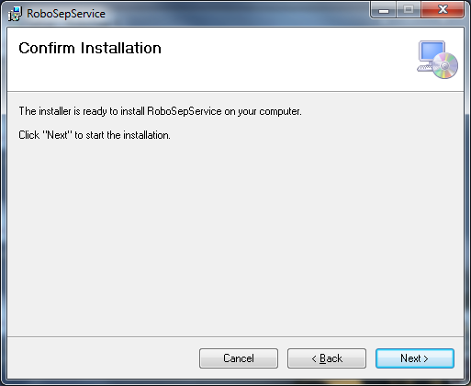

1. Click ‘Close’ button at a following screen. Upgrading RoboSep-S service is completed.

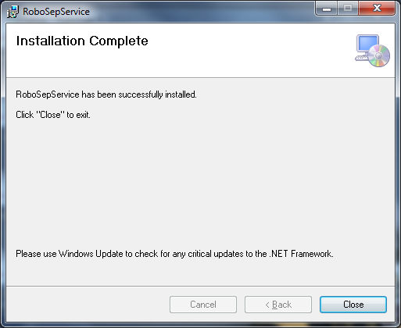

1. Upgrading RoboSep-S editor will be starting. Click ‘Next’ button at a screen below.

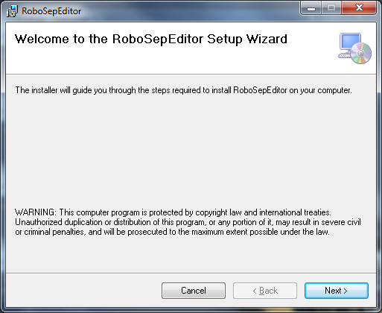

1. Click ‘Next’ button when you see a screen bleow.

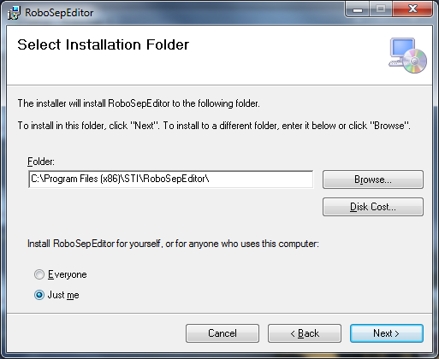

1. Click ‘Next’ button. Copying files will be starting.

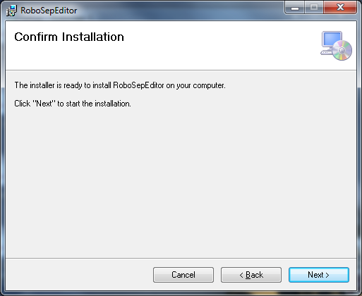

1. Upgrading RoboSep-S editor is completed. Click ‘Close’ button at a following screen.

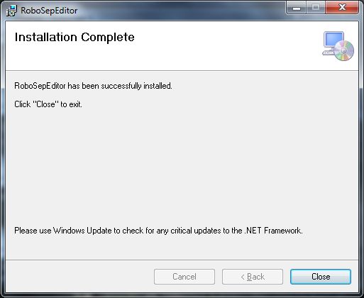

1. Upgrading RoboSep-S program is completed. Click ‘Finish’ button when you see a screen below.

